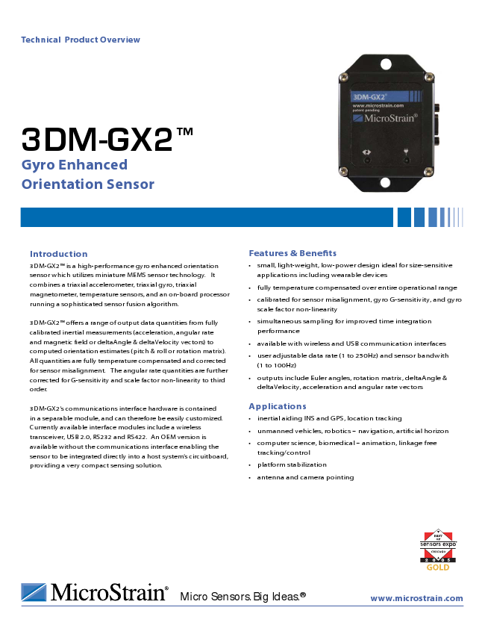
Technical Product Overview
3DM-GX2TM Gyro Enhanced Orientation Sensor
Introduction
Features & Benefits 3DM-GX2TM is a high-performance gyro enhanced orientation
• small, light-weight, low-power design ideal for size-sensitive sensor which utilizes miniature MEMS sensor technology. It
applications including wearable devices combines a triaxial accelerometer, triaxial gyro, triaxial magnetometer, temperature sensors, and an on-board processor running a sophisticated sensor fusion algorithm.
• fully temperature compensated over entire operational range
• calibrated for sensor misalignment, gyro G-sensitivity, and gyro scale factor non-linearity
3DM-GX2TM offers a range of output data quantities from fully
• simultaneous sampling for improved time integration calibrated inertial measurements (acceleration, angular rate
performance and magnetic field or deltaAngle & deltaVelocity vectors) to
• available with wireless and USB communication interfaces computed orientation estimates (pitch & roll or rotation matrix). All quantities are fully temperature compensated and corrected for sensor misalignment. The angular rate quantities are further corrected for G-sensitivity and scale factor non-linearity to third order.
• user adjustable data rate (1 to 250Hz) and sensor bandwith (1 to 100Hz)
• outputs include Euler angles, rotation matrix, deltaAngle & deltaVelocity, acceleration and angular rate vectors
3DM-GX2’s communications interface hardware is contained
Applications in a separable module, and can therefore be easily customized.
• inertial aiding INS and GPS, location tracking Currently available interface modules include a wireless transceiver, USB 2.0, RS232 and RS422. An OEM version is available without the communications interface enabling the sensor to be integrated directly into a host system’s circuitboard,
• unmanned vehicles, robotics – navigation, artificial horizon
• computer science, biomedical – animation, linkage free tracking/control providing a very compact sensing solution.
• platform stabilization
• antenna and camera pointing
Micro Sensors. Big Ideas.®
www.microstrain.com
GOLD
Z Micr0Stra.in®
3DM-GX2TM Inertial Measurement Unit and Vertical Gyro
Specifications The system architecture has been carefully designed to
Orientation range
360° about all axes substantially eliminate common sources of error such as
(pitch, roll, yaw) hysteresis induced by temperature changes and sensitivity
Accelerometer range accelerometers: ± 5 g standard to supply voltage variations. The use of six independent
± 10 g and ± 2 g also available Delta-Sigma A/D converters (one for each sensor) ensures
Accelerometer bias stability ± 0.010 g for ± 10 g range that all sensors are sampled simultaneously, and that the
± 0.005 g for ± 5 g range best possible time integration results are achieved. On-board
± 0.003 g for ± 2 g range coning and sculling compensation allows for use of lower
Accelerometer nonlinearity 0.2% data output rates while maintaining performance of a fast
Gyro range gyros: ± 300°/sec standard, ± 1200°/sec, ± 600°/ internal sampling rate.
sec, ± 150°/sec, ± 75°/sec also available 3DM-GX2 incorporates an integral triaxial magnetometer;
Gyro bias stability ± 0.2°/sec for ± 300°/sec optionally, the magnetometer can be located remotely to reduce hard and soft iron interference.
Gyro nonlinearity Magnetometer range 0.2%
± 1.2 Gauss
Magnetometer nonlinearity 0.4% triaxial accelerometer triaxial angular rate gyros temperature sensors
EEPROM calibration data user settable parameters
Magnetometer bias stability 0.01 Gauss
A/D resolution 16 bits
Orientation Accuracy ± 0.5° typical for static test conditions
± 2.0° typical for dynamic (cyclic) test conditions
six Delta-Sigma 16 bit A/D converters
microprocessor
& for arbitrary orientation angles
Orientation resolution <0.1° minimum
16 bit A/D
w/ embedded software algorithms
Repeatability 0.20°
Output modes acceleration and angular rate, deltaAngle and vectors, Euler angles, Matrix
deltaVelocity, Euler angles, rotation matrix
triaxial magnetometer temperature sensor
Interface options RS232, RS422, USB 2.0 and wireless - 2.45 GHz Wireless 2.4 GHz USB 2.0, RS232, RS422
IEEE 802.15.4 direct sequence spread spectrum, license free worldwide (2.450 to 2.490 GHz) - 16 channels
Wireless communication range 70 m computer
Digital output rates 1 to 250 Hz with USB interface or host
1 to 100 Hz with wireless interface system
Serial data rate 115200 bps
Supply voltage 5.2 to 9.0 volts
Power consumption 90 mA
Connectors micro DB9
Operating temp. -40 to +70°C with enclosure
-40 to +85°C without enclosure
Dimensions 41 mm x 63 mm x 32 mm with enclosure
32 mm x 36 mm x 24 mm without enclosure
Weight 39 grams with enclosure, 16 grams without
enclosure
Shock limit 1000 g (unpowered), 500g (powered)
MicroStrain Inc. 310 Hurricane Lane, Unit 4
ph: 800-449-3878 Williston, VT 05495 USA
fax : 802-863-4093 www.microstrain.com
sales@microstrain.com
Copyright © 2007 MicroStrain Inc. 3DM-GX2 is a trademark of MicroStrain Inc. Specifications are subject to change without notice. Updated July 13, 2007
Patent Pending
Z Micr0Strain°

